Apex’i Power FC on FC3S

Raymond Herchenroder
(special thanks to Chuck Westbrook and Chris Sanders of Banzai Racing)
If any corrections need to be made, you can contact me on the rx7club.com forums, my name on there is arghx .

Latest Update

April 2010: Added information about how to check ignition timing with a timing light.

BASICS

Purpose of this document..........................................2

A. Is the Power FC right for you?
Limitations of the Power FC...................................... 2
Why choose the PFC?.............................................. 2

B. Hardware Choices

Hardware differences between AP PFC and FD PFC................... 3
Sensors ......................................................... 3
Boost Control ................................................... 3

Injectors ........................................................4
Cooling Fan.......................................................4
Ignition System ..................................................4

C. Installation/Preparation

Wiring ...........................................................4
Throttle Body Setup ..............................................5
Checking for leaks................................................6
Starting the Car..................................................7

D. FC Specific Tuning Issues

Tip-in and Accel Tuning...........................................8
Checking Ignition Timing ........................................11

E. Appendix: FD/Power FC ECU Pinout ............................12

Purpose of this document

The purpose of this document is to provide a supplement to all the PFC tuning information out there that is FD-specific. It assumes that you know some very basic information about the Power FC, such as the fact that you need a Datalogit box to access many of the settings. This document is geared more towards those people who want to seriously attempt to tune their car themselves, although it will also be useful for people who just want to get all the miscellaneous stuff taken care of before they go to the tuner. If you’re taking the car to someone else to be tuned, have a long talk with them and see if they are familiar with some of the little differences between tuning an FD and an FC with the Apex’i Power FC.

Still, there really aren’t that many differences between tuning an FC and a single turbo FD. Most of those differences are in throttlebody and TPS setup, and even those are minor, especially if you have a series 5 car. What I would like to do here is first discuss some strengths and weaknesses of the PFC. Then I will discuss the main hardware and wiring choices that an FC owner must make, and then briefly provide some tips on getting the car started and idling, and finally just mention some miscellaneous observations I have made about some aspects of tuning 2nd gen cars.

A. Is the Power FC right for you?

Limitations of the Power FC

Many of the people reading this document right now know that both the Haltech and Microtech are much more common on an FC as a standalone engine management system. I’m not even qualified to give a detailed comparison of the three, but I will go ahead and tell you what the PFC cannot do, or cannot do well:

1. Save you money compared to the other most common engine management options. After you buy the PFC and an adapter kit (or the expensive AP Engineering unit), possibly the Datalogit and some other miscellaneous stuff, there will be probably be no major cost advantage over your other engine management options, depending on how many new parts you purchased.

2. Do “everything.” The PFC still gives you full control of fuel, timing, and a lot of driveability settings, without resorting to the trickery of a piggyback. It has no two-step and cannot directly control methanol injection or nitrous.

3. Replace all your OEM sensors and wiring with non-OEM stuff. You will mostly be using OEM sensors, usually with the exception of the MAP sensor and the IAT sensor if you choose to swap in a fast acting Triumph sensor. You need to make sure your water thermosensor and TPS are in good shape.

4. Give you any serious level of precision in controlling closed-loop parameters or idle speed control/BAC valve solenoid duty cycle. This is kind of a personal nitpick based on my experience using the PFC and completely different systems such as Hondata for Civics and Integras. If right now you don’t understand why this would even matter that much, you probably aren’t going to miss it anyway so don’t worry about it.

Why choose the PFC?

1. It’s a great “entry level” standalone. That doesn’t necessarily mean it’s not suitable for those of us who have more experience with tuning and wiring though. The biggest advantages of the PFC over other standalones are the ease of installation and the large support network of tuning information and professional rotary tuners who support it. Tuning guides are available from Chuck Westbrook and Brian Davies but the actual instructions and support from Apex’i or the makers of the Datalogit aren’t particularly good.

2. Plug-and-Play installation. Provided that your wiring and sensors are good, this eliminates a whole host of problems that you could encounter. If your factory sensors and wiring are in bad shape, you need to get brand new OEM stuff or verified good condition used stuff. You will still have to replace half the sensors anyway (which will be discussed later), and many of the other sensors such as the airflow meter can be removed. The plug-and-play installation means you could return to stock without too much trouble. For most people there is no point in making your own harness for the PFC as that eliminates one of its main advantages. I would just get a different standalone with a flying lead harness.

3. The basemaps available are relatively useable for at least getting your car driving around without boosting.

4. The PFC Commander is a nice thing to have for displaying data and making very minor changes, despite its dated early 1990’s look. I use the peak boost function frequently, and I control boost with the PFC so I can quickly change between low and high boost settings.

5. The PFC controls A/C, the series 5 OMP, while the Banzai Racing adapter kit is already set up to control an electric fan. The fuel and timing maps are 20 x 20 with adjustable breakpoints, which is as good or better than most of the similarly priced options out there. A Datalogit box allows up to 8 analog inputs for logging.

B. Hardware choices

You have two viable options for a Power FC in an FC3S. If you have an S5 car you can run the AP Engineering Power FC, but these have been discontinued and I suspect are still in the $1200 range. Otherwise your best bet is an s4 or s5 specific adapter kit from Banzai Racing, which is a little over $200 for just the adapter harness itself (no sensors).

Hardware differences between AP PFC and FD PFC

This isn’t all that important, but here is what I have figured out so far to be differences between the FD and AP PFC’s. The AP unit has a different factory basemap than the FD, with settings differences such as the stock injector size and stock boost level. So when you reset an AP PFC, your factory injector defaults are 550/550 instead of 550/850 on an FD PFC. The AP PFC can also control the FC trailing ignition and fuel pump without additional wiring necessary.

Sensors

You cannot use the FC MAP sensor or IAT sensor. You must use the FD IAT sensor, and most people prefer the GM 3 bar MAP sensor, although an FD 2 bar sensor or Apex’i 3 bar sensor can be made to work. I’m not entirely sure what the AP Engineering PFC came with, but I think it was the FD MAP sensor (certainly not a GM sensor) and FD IAT. The s5 TPS will work just fine if you have an s5 car, as it is functionally the same as an FD TPS. The s4 TPS will also work, but I will discuss that more later. The water temperature sensor (the one on the water pump housing) will work fine, but make sure yours is in spec. By comparing the PFC Commander display to an aftermarket gauge, I determined that my stock water temp sensor was reading way too cold, which will affect the tuning. A new one from Mazda is something like $40.

I have recently switched to a Triumph motorcycle air temperature sensor.

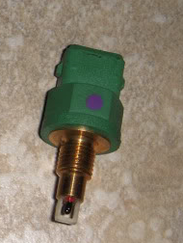

They are a light green color and have the same connector as a typical Bosch fuel injector (same as series 4 86-87 ½ injectors). These sensors have an exposed element and thus respond faster than the OEM FD sensor. You can adapt this to the factory series 4 plug by taking a fuel injector connector pigtail and crimping on two small male spade connectors. This will fit into the factory IAT sensor harness plug.

Boost Control

The AP Engineering Power FC works with the optional boost control kit just fine (solenoid plugs into the factory boost control solenoid plug on the s5 cars). If you don’t have an s5 with the AP Engineering PFC, the pin which duty controls the solenoid is listed in the appendix. You can use that pin to pulse the ground and then supply ignition powered +12v to the other wire on your solenoid. A factory s5 or FD boost control solenoid will work. I use a factory FD solenoid to control boost on my 88 model. You can also use any typical 3 port boost control solenoid (GM etc).

If you do not have the boost control kit, you will need to set all the Turbo Transition Low settings to 1800 and the High settings to 2000 in Settings 1 of the Datalogit. Sequential turbo control MUST be enabled for cars without the boost control kit.

Injectors

All the rules for injector impedence on a 2nd gen car apply to the Power FC. I have an 87 harness with the factory resistor pack and it works just fine. If your car has high impedence injectors stock, Banzai Racing will solder in some resistors into the adapter harness for aftermarket low impedence injectors, if you select that option when you order. The benefits of the FJO injector driver are beyond the scope of this article. Basic injector setup is covered in the Power FC manual but more settings can be accessed with a Datalogit. If you need to wire in your own resistors, the pins are listed in the appendix at the end of this document. I would recommend 10 watt, 6 ohm because that is what Mazda uses from the factory in the earlier production s4 cars.

Cooling Fan

On the Banzai Racing kit, the green diagnostic connector (s4 and s5 locations are different) is configured to pull ground on a relay to trigger an electric fan (See Appendix). This will eliminate some redundant wiring if you do an e-fan conversion. Banzai Racing has information about this on their website.

From my testing, I have determined that the PFC has built-in hysteresis control for the fan. What this means essentially is that if you set the trigger temperature (all 3 boxes in settings 3 of the DL) to 87 C (about 186ish F), the fan will switch on at 86 C and cut off if the temperature comes down to about 85. This keeps it from cycling too rapidly. On a car with the OEM 180 degree thermostat it would typically hover around 86 C in traffic with the fan running.

Ignition System

As this is a plug-and-play standalone, the FC Crank Angle Sensor requires no modification. As far as spark upgrades, I’ve had good luck with the HKS Twin Power. It does not have a plug-and-play harness for the FC like it does for the FD, but there’s only 4 wires to splice in and you don’t have to cut anything. The Banzai Racing adapter kit, which uses the FD PFC and requires modification of the trailing coil, does not affect installation. Just follow the instructions—surprisingly the diagrams that come with the Twin Power are very good. Remember that the HKS Twin Power is not compatible with non resistor plugs according to the manufacturer, so that means no B10EGV. MSD, Crane, etc. will also connect just like they would on a stock car, but I prefer the compact installation and simplicity of the HKS Twin Power.

C. Installation/Preparation

Wiring

If you have an s5 car with the AP Engineering Power FC, you just need to install the IAT sensor and MAP sensor, then plug in the harness and go.

If you are using a Banzai Racing adapter kit, follow their writeup. If you plan to do any serious datalogging I would hook up both the vehicle speed sensor and knock sensor, but otherwise they don’t affect the operation of the vehicle. All those wires are labeled on the adapter harness, but I have the pins listed in the Appendix of this document as well. You also need to do some wiring to the trailing coil. Be very careful with this, and follow the Banzai Racing writeup closely. Also be very careful with your wiring of the Circuit Opening Relay, as the pump will shut off if this isn’t hooked up correctly. The fuel pump check connector (yellow two-prong connector that you can jumper on passenger side shock tower) should make the fuel pump run constantly in case you need to troubleshoot this wiring.

Regarding the TPS, if you have an s5 TPS everything is straightforward. Just use the Etc → Sensor Check function to see if the voltages are in spec (see Appendix) and replace or adjust it if necessary. If you have an s4 car, you need to splice the unterminated full range TPS wire (this is labeled on the adapter harness) into the narrow range TPS wire that is already connected on the adapter harness. Most s4 owners are used to using that checker light or an ohmmeter to set the TPS. You need to forget that and set it according to the voltages I have listed in the appendix (which is straight from the FD factory service manual), by using the sensor check function.

Throttle Body Setup

(see picture at end of this section)

Although it is common to strip down the throttlebody (“TB mod”) during emissions removal, I find that the car will drive a lot better if you still have your thermowax/fast idle cam and dashpot installed, especially if you have no BAC valve. You can ditch the double throttle system or leave it, it doesn’t matter that much in my opinion, and I won’t discuss it further here. The purpose of the thermowax is to mechanically raise the idle by opening the throttle plates when the engine is cold. I honestly think it’s worth keeping that pesky coolant hose on the rear iron for this, as I hated keeping my foot on the gas (or setting the base idle somewhat high with the throttle stop screw) when I had my thermowax removed on stock ECU with no BAC valve. The throttle stop screw (pictured below, you need to loosen the hex nut to turn it) adjusts how far open the throttle plates will be with your foot off the gas pedal, and is especially important for setting the idle if you have no BAC valve. Also note that the FC turbo throttlebody has no direct equivalent of the Air Adjust Screw on the FD throttlebody that you may read about for idle adjustment procedures. Bypass air adjustments are done on the BAC valve itself.

There are adjustment procedures for the fast idle cam and stop screw in the factory service manual, but honestly I had no luck with them. It’s really hard to measure those throttle body clearance specs even with feeler gauges, so even if you think you have your throttlebody “to spec” the idle is not where you want it to be, and those specs are for a bone stock car on the stock ECU anyway. Don’t mess with any of these adjuster screws at all unless you really aren’t happy with the way the car idles. Serious idle tuning requires adjusting not just the throttlebody, but also the fuel map and possibly timing if you are running manual idle control (see Chuck’s notes about that). For those of you who are not running manual idle control, just make sure you do the idle learn procedure in the PFC manual. When tuning a car, it’s very easy to make it run worse before it runs better, and idle tuning is no exception. Don’t just blindly start messing with any aspect of your throttlebody.

The dashpot is something else you may or may not need to adjust at some point if you find the car stalling randomly. It slows the closing of the throttle plates as you let off, and is especially useful if you have no BAC valve to help keep the idle stable. I found my car a lot less prone to stalling around town with this adjusted correctly, but I do have a puck clutch and lightweight flywheel that may make it more prone to stalling than some cars. There is a spec in the factory service manual for the dashpot, but your best bet is to just play with it. Loosen the hex nut on the underside of the mushroom-looking thing, and then turn the whole dashpot. If you’re not careful the idle will stick a bit from over adjusting it.

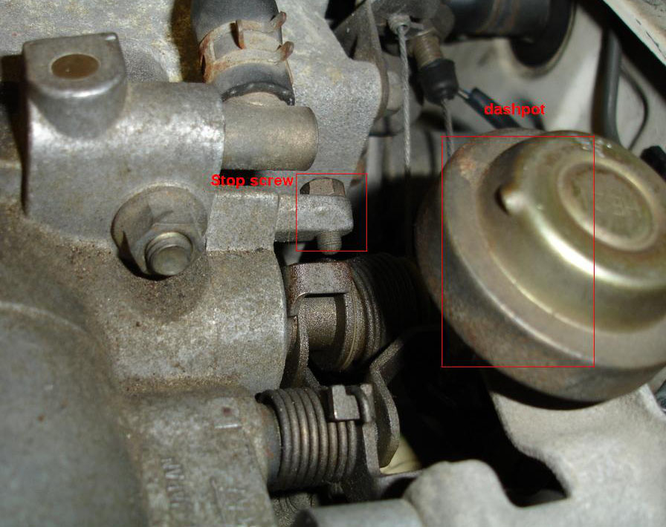

Checking for leaks

It’s likely that you are installing the PFC as part of a larger upgrade project on the car. You can check for fuel leaks without even running the car (you don’t even need the intake manifold installed) by using the yellow fuel pump check connector on the passenger side, so that’s easy enough. It is also vital though that you pressure test for boost/vacuum leaks! Don’t just say “oh, I double checked my plumbing, there’s no boost leaks.” Or “I’ll just spray some carb cleaner with the car running, that’ll do it.” No, it won’t, not if it turns out that your vacuum leak is so bad that the car won’t idle long enough to spray carb cleaner (ask me how I know). Air leaks when the car is under vacuum will affect driveability and air leaks under boost will rob you of power and response, not to mention throw off your entire tune, requiring more work if you fix them later.

You can’t be absolutely sure if air is leaking without putting the system under pressure. At the time of this writing, you can get a simple and cheap pressure tester from www.boostpro.net/prodtester.html (get the universal tester), or just make one out of Home Depot parts for even cheaper. You may need a coupler or 4”→ 3” reducer depending on your intake setup to make this work. Hook the tester up, watch the gauge rise, and spray soapy water around the engine bay, especially near blockoff plates, under the UIM, and near intercooler piping couplers. Pressure testing helped me locate a leaky blockoff plate, a tiny leak at the IAT sensor, leaky OMP air bleed lines (use 5/32” hose or equivalent on those small barbs, it won’t leak then), and a poorly adjusted blowoff valve. None of these could have been found by a visual check. If you still have your stock intercooler, I have seen pictures of crossover pipes made out of Home Depot plumbing to replace the intercooler for diagnostic tests. You will have much better access to the back of the engine and you can fiddle with the throttlebody screws with the car idling.

Again, don’t tune the car unless it is mechanically and electrically sound beforehand, I can’t emphasize this enough.

D. Starting the Car

If you have a Datalogit (and you probably should), connect it and save a copy of whatever tune was in the PFC when you bought it. Obviously if it's brand new it's going to be the factory base map, but if the unit is used it may have some changes. It's useful to keep these saved files for reference. If you don't have a brand new PFC, reinitialize your Power FC using the datalogit or the Commander (Etc → Initialize), and remember to turn the key off and then turn it back on. This resets the idle learning procedure, instructions for which are available in the PFC manual on the Apex’i web site.
Load your map in there, turn the key, and hopefully it will fire right up. Then you can check for spark at the trailing coils if you had to do any trailing coil wiring. If the car starts but won’t idle without your foot on the gas, check your wideband and see if it’s reading insanely rich or lean. In my case, I had to adjust the map because it was too lean for my setup due to things like injector flow rates, porting, etc.
At this point your car should hopefully be running and idling, perhaps well or perhaps poorly. You can now attempt to get the vehicle to the tuner or tune it the rest of the way yourself. Take your time and don't even pull the car out of the garage until you're sure it will idle decently and is mechanically sound, unless you want to be calling a tow truck ten minutes later.

E. FC-Specific Tuning Issues

Tip-in and Accel Tuning

Tip-in, throttle response, and starting from a stoplight can be very frustrating to tune. Coming off a stoplight there are a number of cells in the INJ/basemap that can affect this. My problem was that I could get the car to start smoothly from a dead stop, but it would still peg lean from small throttle movements if the car were coasting in gear. Most people try adding some to the Accelerate Injector table in the commander and settings 2 of the Datalogit. That helped some, especially from a dead stop. But in my experience, at least on a series 4 Turbo II with a brand new s4 TPS, it still didn’t address the hesitation and superlean condition from small throttle movements with the car already moving.

So I experimented with INJ vs TPS 1 in settings 2 of the Datalogit. As Chuck’s notes mention, this setting applies the numbers from the Accelerate Injector table based on the rate of throttle movement. On my car at least, I found an improvement in response by lowering the values in the 2nd and 3rd rows of this table. This makes the PFC kick in more fuel for smaller throttle movements, but also required me to adjust some of the fuel map cells right off the idle area so that they aren’t too rich. If you over adjust these values the car will dump in fuel even on the highway from low cruising, so be careful if you attempt this. Here are my current settings:

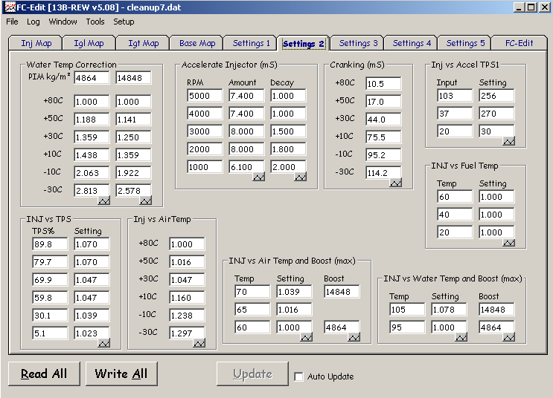

Here are the stock settings:

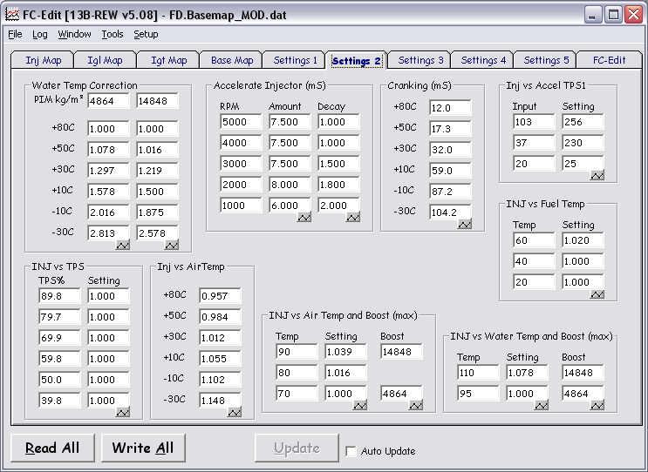

I have also been playing around with INJ vs TPS. On an s4 FC (with narrow range TPS only) I am currently using these settings:

TPS % - Setting

89.8 – 1.070
79.7 – 1.070
69.9 – 1.047
59.8 – 1.047
30.1 – 1.039
5.1 – 1.023

That helped throttle response without making AFR’s super rich on slight throttle movements, as the the INJ vs Accel TPS1 table can do. Note that changing this map may require some retuning of the main fuel maps (INJ and Base).

Checking Ignition Timing

When checking ignition timing, warm the engine up so that water temperature reaches about 80 C on the Commander. Go to etc. → function select and turn off Idle IG control if it is on. Now go to your monitor screen and verify that leading ignition is -5 L and trailing ignition is -20 T. Then use your timing light to see if the marks line up, just like you would with the factory computer. If you want idle IG control on you can then re-enable it when you are finished.

The Banzai Racing basemaps are a decent starting point for leading and trailing ignition timing. Remember that s4 cars have lower compression rotors than s5 and FD’s, so they might be able to get away with a little more boost or a little more timing, but that’s a judgment call that is best made on a dyno.

Appendix (FD pinout, same as Power FC)

(diagram is from the back of the connector, with the wires facing you)

Boost control/Wastegate Solenoid duty signal: FD pin 4U, use for boost control kit or other boost control solenoid

Fan (cooling): FD pin 3D

Fuel pump relay: FD pin 1T , will trigger ground on FC circuit opening relay

Injector (Front Primary): FD pin 4W

Injector (Front Secondary): FD pin 4X

Injector (Rear Primary): FD pin 4Y

Injector (Rear Secondary): FD Pin 4Z

Knock Sensor: FD pin 3M

RPM switch: FD pin 4R, switched ground, controllable by sequential turbo transition settings in Datalogit Settings 1 screen

TPS: Full range (VTA1 in the Commander sensor display): FD pin 3G
Factory spec: (s5/FD TPS) 0.1 – 0.7 v, pedal released, engine warm. 4.2 – 4.6 volts WOT, engine warm. S4 TPS should have VTA1 and VTA2 read the same.

TPS: Narrow range (VTA2 in the Commander sensor display): FD pin 3F
Factory spec (s4/s5/FD TPS): 0.75 – 1.25 pedal released, engine warm. 4.8 – 5.0 at WOT. For an s4, unless you have almost a brand new sensor, you probably won’t be able to get 4.8 volts at WOT with the screw adjusted correctly.

Vehicle speed sensor: FD Pin 1M

