Banzai Racing FD3s Pulsation Damper Elimination How-To

If you are planning to perform this modification you will need to have sufficient mechanical working knowledge of your car. This ‘How To’ is based upon the fact that you are previously capable of removing the Fuel Rails. If you do not feel that you can perform a vacuum line job, you should not attempt this modification.

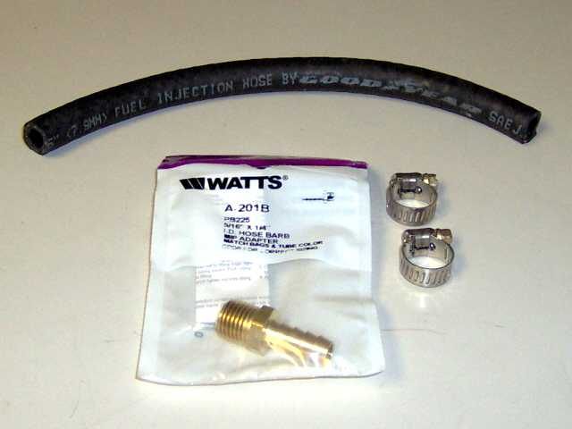
Parts Required

- 5/16" Hose Barb x ¼" (MIP Adapter) NPT fitting (available at most local hardware stores; e.g. Watts part # A-201B from Lowes
- Teflon Tape
- 2 x 1/8 - 5/16" Hose Clamps (New P/N: 6204, Old P/N 6202)
- 6 - 8 inches of 5/16" Goodyear Fuel Injection Hose (SAE J30R9)

Tools Required

- Screwdriver
- 14mm Wrench
- 1/4 - 18 size tap
- Pliers
Procedure

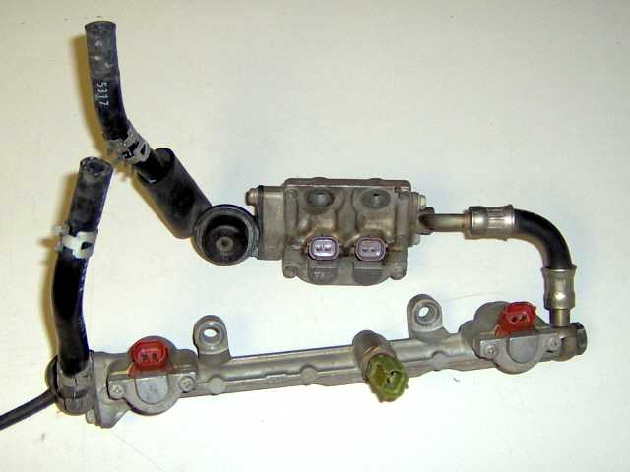
Step 1

- Disconnect the battery. Then remove upper intake manifold (UIM), release fuel pressure, and then remove fuel rails.
- Place fuel rails on a clean dry surface for work purposes.

Step 2
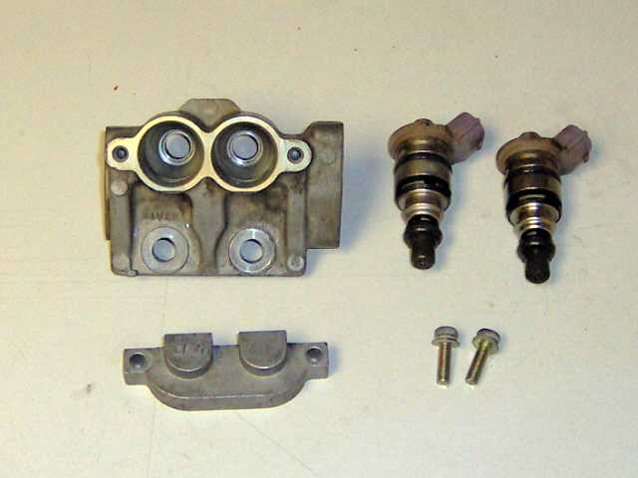
- Remove primary fuel injectors (this may require some patience) DO NOT use a screwdriver; this will crack the injector connector. I remove them by spinning the injector back and forth while pulling. Remove PD and secondary fuel rail fuel line.

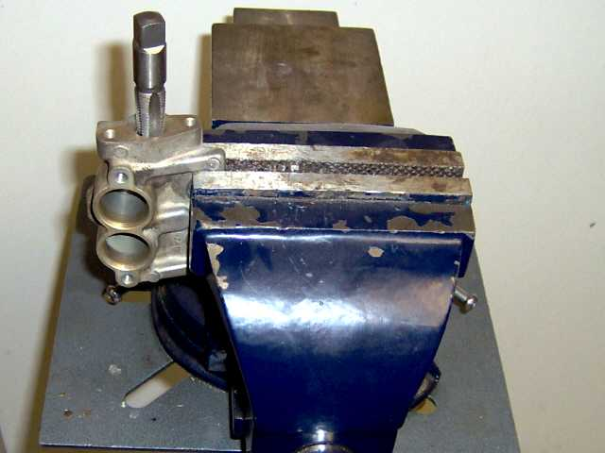
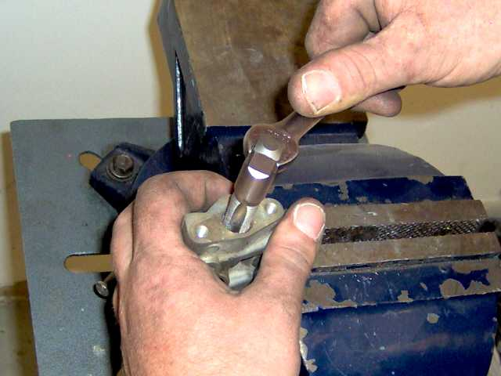
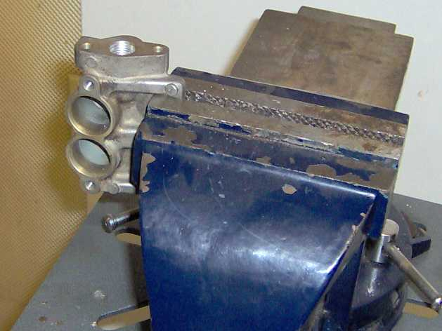
Step 3

- Now that you have stripped down the primary fuel rail you will need to tap it. Place flat portion of fuel rail in vice as shown.
- Using a 1/4 - 18 size tap, you will need to thread until it bottoms out in the fuel rail, ensuring that you keep it as straight as possible.
- Examine threads

Step 4

- Clean fuel rail (using compressed air, WD-40, etc.); ensure that no shavings remain.

Step 5
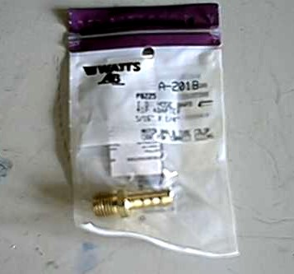
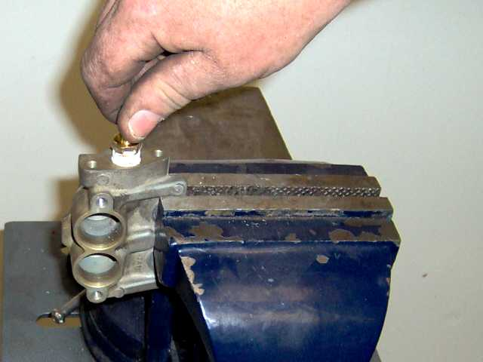
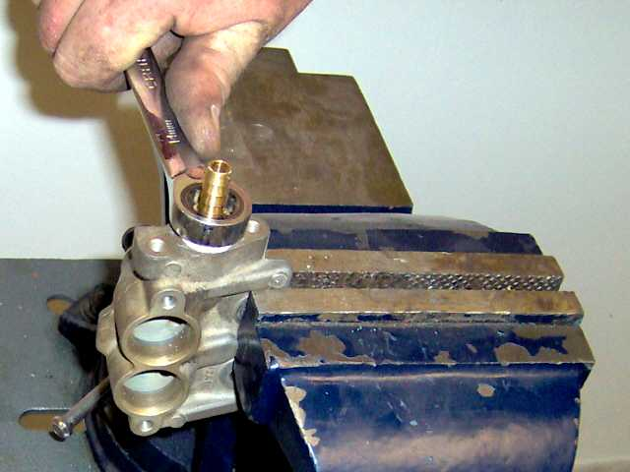

- Using a 5/16 " Hose Barb x ¼ " (MIP Adapter) NPT fitting (available at most local hardware stores; e.g. Watts part # A-201B from Lowes.
- Apply Teflon tape to threads of fitting, and screw into newly tapped fuel rail
- Then using wrench, tighten down completely.

Step 6
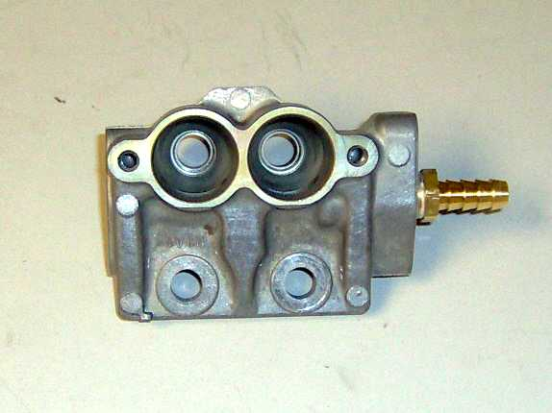
- Inspect O-ring on secondary fuel line feed, replace if worn, and reinstall into primary fuel rail.
- Inspect O-rings on primary injectors, replace if necessary.
- Reinstall primary injectors.

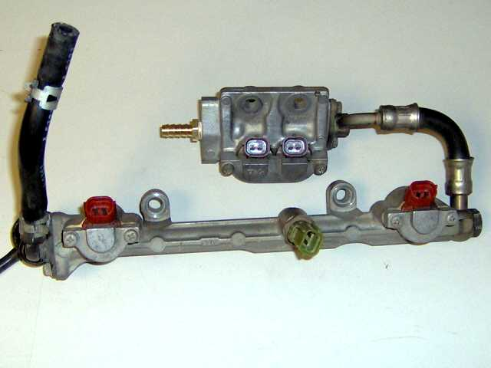
Step 7

- Connect fuel rails back to fuel lines prior to installation for testing purposes. Re-connect the battery, prime the fuel system and check for leaks. If there is a leak identify source and repair. Problem area could be; fuel injector O-rings.
- No Leaks; then install fuel rails in car.
- This is also a good time to replace the fuel hose on your primary fuel line feed. This requires 5/16" high-pressure fuel injection hose, available at any auto parts store.

Step 8
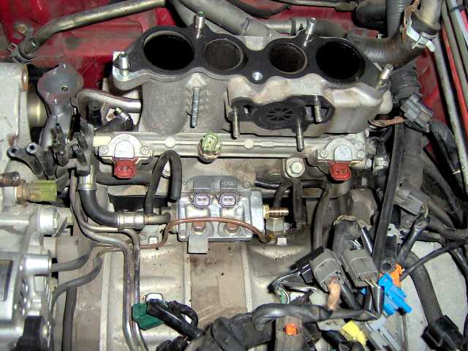
- And finally, quote directly from FSM "Installation is reverse of removal"

Banzai Racing Inc. is not responsible for any adverse effects due to this or any modification

Visit our website at www.banzai-racing.com

